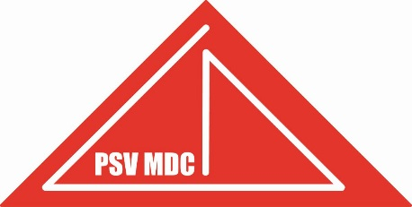
ENTRY FORM PSV MASTER DIVING CUP
1 – 2 – 3 March 2024

NAME
SURNAME
DATE OF BIRTH
COUNTRY
TEAM
EMAIL AND PHONE
MALE/FEMALE
NAME JUDGE

I AM 19 YEAR OR OLDER IN 2024, I HAVE THE DUTCH NATIONALITY AND I WANT TO DIVE ALSO FOR THE OFFICIAL KNZB NK MASTER SCHOONSPRINGEN:
O YES
O NO

SINGLE EVENTS
OPEN | 1m |  | 3m |  | PLATFORM
MASTERS | MALE | FEMALE | MALE | FEMALE | MALE | FEMALE
18-24
25-29
30-34
35-39
40-44
45-49
50-54
55-59
60-64
65-69
70-74
75-79
80+

REGISTRATION SYNCHRO EVENTS NEXT PAGE!

SYNCHRO EVENT DIVINGBOARD
The SUM of the ages determine the age group:
SYNCHRO | 3m DIVINGBOARD
MASTERS | MALE | FEMALE | MIX
18-49
50-99
100 +
MIX COUNTRY SYNCHRO IS NOT ALLOWED FOR THE DUTCH SYNCHRO. ONLY ALLOWED FOR THE OPEN PSVMDC
NAME DIVER 1
DATE OF BIRTH DIVER 1
NAME DIVER 2
DATE OF BIRTH DIVER 2

SYNCHRO EVENT PLATFORM
The SUM of the ages determine the age group:
SYNCHRO | PLATFORM
MASTERS | MALE | FEMALE | MIX
18-49
50-99
100 +
MIX COUNTRY SYNCHRO IS NOT ALLOWED FOR THE DUTCH SYNCHRO. ONLY ALLOWED FOR THE OPEN PSVMDC
NAME DIVER 1
DATE OF BIRTH DIVER 1
NAME DIVER 2
DATE OF BIRTH DIVER 2

ENTRY
Entry fee will be € 20,00 per diver single event.
Entry fee will be € 20,00 per synchro event. The fee will be € 10,-- per diver per synchro event.
REGISTRATION
Please email this form to: psvmasterdivingcup@gmail.com
Final registration date is 10th of January 2024.
Because of the limited pool hours be on time with your registration! Dutch divers have priority. Full is Full.
